EXAMINATION OF DRAFT REGULATORY LEGAL ACTS

Petrova Veronika Alexandrovna
Candidate of juridical sciences, associate Professor, Amur State University,
Russia, Blagoveshchensk

Ivanova Elena Viktorovna
Student, Amur State University,
Russia, Blagoveshchensk

The text of the article. The text of the article. The text of the article. The text of the article. The text of the article. "Quote" [1, p. 35]. The text of the article. The text of the article.

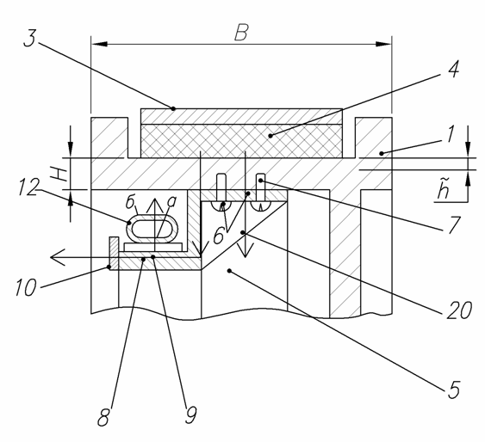
Figure 1. The name of the figure

The text of the article. The text of the article. The text of the article. The text of the article. The text of the article. "Quote" [1, p. 368]. The text of the article.
(1)
где: the amount of heat used to heat the pulley;
mass of cargo moving at initial speed ;
mechanical equivalent of thermal work;
coefficient taking into account the conversion of kinetic energy into other types of non-thermal energy, uneven distribution of specific pressure and the actual contact area of the phase transition;
distribution coefficient of heat flux FP.
The text of the article. The text of the article. The text of the article. The text of the article.
Table 1.
Table name
Text | Text | Text | Text | Text
Text | Text | Text | Text | Text
Text | Text | Text | Text | Text
Text | Text | Text | Text | Text

The text of the article. The text of the article. The text of the article. The text of the article. The text of the article. "Quote" [2]. The text of the article.
References:

